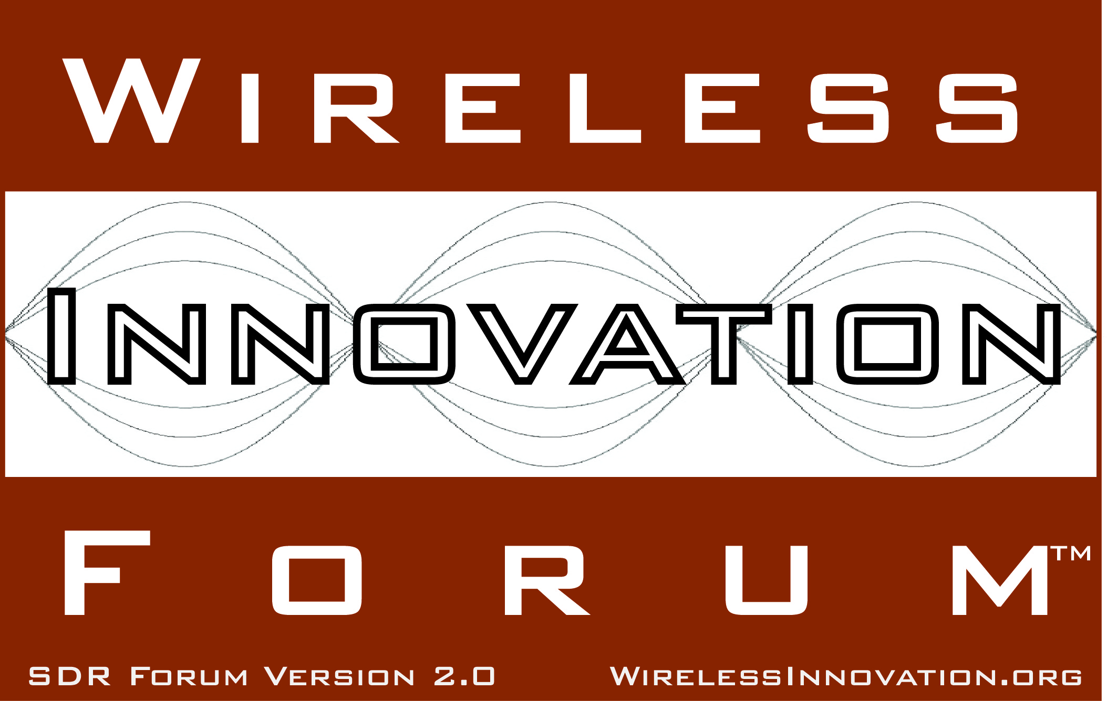

Vanderbilt University, Drexel University and Stevens Institute of Technology Students Take Awards in 2013 Software Defined Radio Challenge

For Immediate Release
WASHINGTON, DC, 18 July 2013 – The Wireless Innovation Forum (www.WirelessInnovation.org), a non-profit international industry association dedicated to driving the future of radio communications and systems worldwide, announced the winners of the 2013 SDR Design Challenge, which was held at Virginia Tech on Wednesday, May 29, 2013, during the annual Wireless @ Virginia Tech Symposium and Wireless Summer School in Blacksburg, VA.
This student contest, sponsored by the Wireless Innovation Forum and Wireless @ Virginia Tech, initially involved six teams working on a broad range of project topics related to software defined radio. Judges for this year’s symposium were Ben Hilburn from Ettus Research, James Neel of Cognitive Radio Technologies and Richard Taylor of Harris Corp. Special thanks to Ettus Research for also supplying this year’s award trophies.
Results of the competition were:
FIRST PLACE: Team Marmote (Vanderbilt University) represented by Sandor Szilvasi and Benjamin Babjak, Advised by Akos Ledeczi and Peter Volgyesi,
Project Title: “Low-Power Software Defined Radio for Wireless Sensor Network Experiments”

SECOND PLACE: Team DWSL (Drexel) represented by Nikhil Gulati and Damiano Patron, Advised by Kapil Dandekar,
Project Title: “SDR Integrated Cognitive Antenna System”

THIRD PLACE: Team Attila (Stevens Institute of Technology) represented by Vidya Sagar, Advised by R. Chandramouli, and K. P. Subbalakshmi.
Project Title: “Application QoS Aware Cognitive Wireless Networking”
Final reports for each team can be found here: http://groups.winnforum.org/p/cm/ld/fid=366.
More information about the Challenge can be found here: http://groups.winnforum.org/p/wi/et/wid=24%20.

# # #
About the Wireless Innovation Forum
Established in 1996, The Wireless Innovation Forum (SDR Forum Version 2.0) is a non-profit mutual benefit corporation dedicated to driving technology innovation in commercial, civil, and defense communications worldwide. Members bring a broad base of experience in Software Defined Radio (SDR), Cognitive Radio(CR) and Dynamic Spectrum Access (DSA) technologies in diverse markets and at all levels of the wireless value chain to address emerging wireless communications requirements. To learn more about The Wireless Innovation Forum, its meetings and membership benefits, visit www.WirelessInnovation.org.

Editorial Contacts
Lee Pucker, 604-828-9876, Lee.Pucker@wirelessinnovation.org or
Stephanie Hamill, 970-290-9543 or Stephanie.Hamill@wirelessinnovation.org

